20 May 2013

Mrs Mehri Madarshahi-d’Orville
President, Global Cultural Networks
Paris , France

Dear Mrs Madarshahi,

Please join us 6–8 June 2013, for the Fortune Global Forum in Chengdu, China. This major event will bring together the CEOs of the world’s most important companies, leaders from China’s new government, and innovative thinkers from around the world.

China will be at the center of the discussions, but our program will be global in scope. The theme is “China’s New Future,” with a focus on emerging opportunities in the domestic economy, the development of Western regions, and China’s changing role in the world. In addition to the business program, the Fortune Global Forum offers a rich personal experience and opportunities for high-level relationship building, from the gala opening dinner to small group roundtables to an intimate dining experience on the second night. Your companion is also invited to join you for the dinners and to participate in an extraordinary concurrent program. Chengdu has become a magnet for multinational companies, a center for higher education, and a leader in a diverse range of industries—an ideal location for the Forum.

A distinguished assemblage of leaders, from 32 countries and the full spectrum of industries, have committed to join us, including the chairmen, presidents, and CEOs of Alliance Boots, Anheuser-Busch InBev, ANZ, Coca-Cola, Delta Air Lines, DuPont, GE, Honeywell, International Paper, Jardine Matheson, Johnson & Johnson, JPMorgan Chase, Marubeni, McKinsey, Nokia, Novartis, Petronas, PTT, Ranstad, Royal Philips Electronics, SAP, Schneider Electric, Scotiabank, Standard Chartered, and Walt Disney. Also joining us will be the leaders of China’s top companies, including Ansteel, Baidu, Baosteel, ChemChina, China Huadian, CNAF, China National Building Materials, China Railway Group, China Railway Materials, China Unicom, Henan Coal Chemical, Jizhong Energy, Lenovo, Shandong Weiqiao Pioneering, Shanxi Coal Transportation and Sales, Sina, Sinomach, Sinopec, Tianjin Materials and Equipments, Xinxing Cathay International, and Zhejiang Geely. Fortune will cover the Forum in the pages of the magazine and online, and we expect over a hundred domestic and international journalists at the event.

The cornerstone of the Fortune Global Forum is dialogue among its participants and your participation will be a valuable addition. Please register DV VRRQ DV SRVVLEOH at www.FortuneGlobalForum.com (where
you will also find the most up-to-date program and participant list). We hope to see you in Chengdu in June.

Best regards,

Andy Serwer

Ceos from the Fortune Global 500 will meet in Chengdu
for the 2013 Fortune Global Forum.

the fourth Fortune Global Forum to be held in China follows previous successful meetings in Shanghai, Hong Kong SAr, and Beijing.
Since 1995, the Fortune Global Forum has convened the leaders of global business—the Ceos of the world’s largest companies—on the dynamic frontiers
of international commerce. In 2013, we’ll meet in Chengdu, a thriving city in western China, for a program that will focus on the monumental changes that are defining China’s future and shaping the course of global business for the 21st century.

With dramatic shifts underway in every major economic sector, the demands of global competition are intensifying and new consumer sensibilities are
emerging. How will Ceos and government leaders deal with these changes? What new approaches are needed to harness
the potential of a growing new class of consumers? What role will multinational companies play in the next phase of China’s development? We will address these questions and more at the 2013 Fortune Global Forum.

to ensure the highest level of interaction, participation is by invitation only and limited to chairmen, Ceos, and other leaders selected by the editors of
Fortune. Complimentary registration is extended to spouses, who are invited to attend the gala evening events and selected activities, and to take part in an extraordinary concurrent program
exploring the diverse culture and special experiences unique to Chengdu.

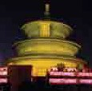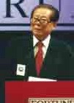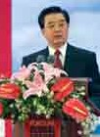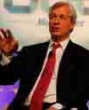
Fortune Global Forum Photos by BradMarkel.com

For more information: www.FortuneGlobalForum.com

2013 PARTICIPANTS

List in formation. Selected confirmed participants as of 15 April 2013.

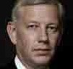Angela Ahrendts Chief executive officer Burberry Group PLC

Richard Anderson Chief executive officer Delta Air Lines, Inc.

Dominic Barton
Worldwide Managing Director McKinsey & Company

Jeffrey Bewkes Chairman and Ceo time Warner Inc.

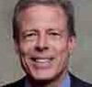Carlos Brito
Chief executive officer
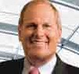Anheuser-Busch InBev nV/SA

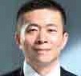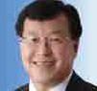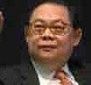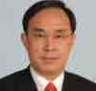Chang Xiaobing
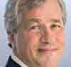Chairman China unicom

Charles Chao Chairman and Ceo Sina.com

Victor Chu
Chairman
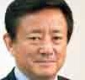First eastern Investment Group

Pailin Chuchottaworn President and Ceo Ptt Public Co. Ltd.

David Cote Chairman and Ceo Honeywell

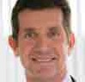Jamie Dimon Chairman and Ceo JPMorgan Chase & Co.

Stephen Elop President and Ceo nokia Corp.

Fan Gang
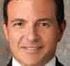Director national economic research Institute

John Faraci Chairman and Ceo International Paper Co.

AlexGorsky Chairman and Ceo Johnson & Johnson

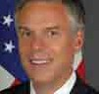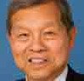Yukon Huang
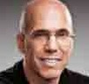Senior Associate Carnegie endowment for International Peace

Jon Huntsman
Former u.S. Ambassador to China

Robert Iger
Chairman and Ceo the Walt Disney Company

Jeffrey Immelt Chairman and Ceo Ge

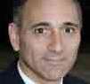Joseph Jimenez Chief executive officer novartis AG

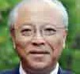Jeffrey Katzenberg
Chief executive officer DreamWorks Animation SKG, Inc.

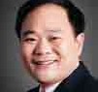Muhtar Kent Chairman and Ceo the Coca-Cola Co.

Tadakazu Kimura President and Ceo Asahi Shimbun Co.

Victor Koo
Founder, Chairman, and Ceo Youku, Inc.

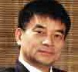Ellen Kullman Chair and Ceo DuPont

Robin Li
Founder, Chairman, and Ceo Baidu

Li Shufu Chairman Zhejiang Geely
Holding Group Co. Ltd.

Kenneth Lieberthal
Senior Fellow, John L. thornton China Center
the Brookings Institution

Joe Liemandt Founder and Ceo trilogy, Inc.

Liu Yonghao
Chairman new Hope Group

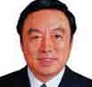Joe Lonsdale
Partner Formation8 Partners LLC

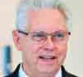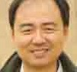Ma Jun Founder and Director Institute of Public and environmental Affairs

Ma Weihua
President and Ceo
China Merchants Bank

Sheri McCoy Chief executive officer Avon Products, Inc.

Jennifer Yuh Nelson
Director
Kung Fu Panda 2 and
Kung Fu Panda 3

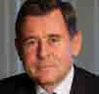Henry Paulson
Former Secretary
u.S. treasury

Stefano Pessina executive Chairman Alliance Boots

François-Henri Pinault Chairman and Ceo Kering (formerly PPr)

Georges Plassat Chairman and Ceo Carrefour SA

Bridgette Radebe executive Chairperson Mmakau Mining

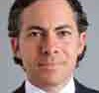Joshua Cooper Ramo
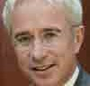Vice Chairman Kissinger Associates, Inc.

Peter Sands Group Chief executive Standard Chartered PLC

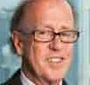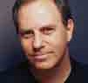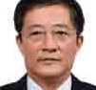Ren Jianxin President ChemChina

Andy Serwer Managing editor Fortune

Stephen Roach
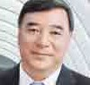Senior Fellow, Jackson Institute Yale university

Song Zhiping
Chairman
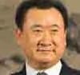China national Building Materials Group

Judith Rodin
President
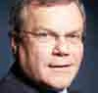the rockefeller Foundation

Sir Martin Sorrell Chief executive WPP

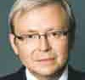The Hon. Kevin Rudd Former Prime Minister Australia

Jean-Pascal Tricoire President and Ceo Schneider electric

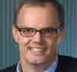Frans van Houten
Chairman and Ceo royal Philips electronics

Frits van Paasschen President and Ceo Starwood Hotels & resorts Worldwide, Inc.

Wang Jianlin
Chairman
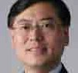Dalian Wanda Group Co., Ltd.

Rick Waugh
Chief executive officer Scotiabank

Meredith Whitney
Founder and Ceo Meredith Whitney Advisory Group

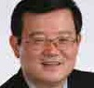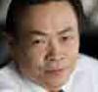Xu Lejiang
Chairman Baosteel Group Corp.

Janet Yang
President
Janet Yang Productions

Yang Yuanqing Chairman and Ceo Lenovo Group Ltd.

Zhang Yue Chairman BroAD Group

Zhao Baige executive Vice President red Cross Society of China

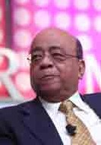PRoGRAm PIllARS

Pillar 1: The China Century

Our program will examine the forces contributing to the rise of China as an economic superpower, from demographics to the changing face of Chinese business. We’ll address the challenges China faces, including delivering sustained growth and rising incomes while boosting business and government transparency.

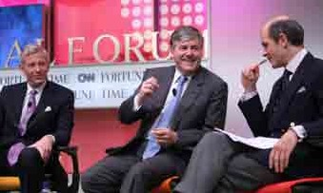Pillar 2: Sustainable Development

With the inexorable march of urbanization, finding ways to nourish, house, transport, and protect people—without depleting the earth of its resources—is one of the critical issues of our time. We’ll take a close look at China’s vast portfolio of green initiatives, and the country’s massive resource needs.
Fortune Global Forum Photos by BradMarkel.com

Pillar 3: Innovation and Technology
What are the new discoveries that will transform business and society in the coming decade and who will invent them? How will the widespread availability of broadband and the ability to access the “cloud” continue to change the way global populations live and work?

Pillar 4: Global Finance and Economic Recovery
What are the lessons from the last five years of economic turmoil? We’ll explore the role of nascent economic superpowers, and the challenges of the new, hyperconnected global economy.

PRoGRAm AT A GlANCE

WEDNESDAy, 5 JuNE
18.00–19.30 Fortune Most Powerful Women reception

ThuRSDAy, 6 JuNE
8.00–10.00 Fortune Most Powerful Women Breakfast 8.00–12.00 Chengdu tours
9.00–14.30 roundtables
15.00–17.00 Business Sessions
18.30–21.45 Welcoming reception and Gala Dinner

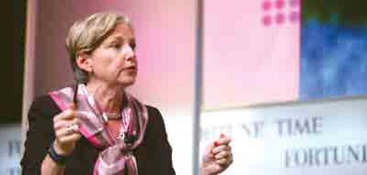FRIDAy, 7 JuNE
8.30–17.00 Business Sessions 18.30–22.00 reception, Dinner, and nightcap
Fortune Global Forum Photos by BradMarkel.com

SATuRDAy, 8 JuNE
8.30–13.00 Business Sessions
13.00–14.00 Closing Luncheon

SuNDAy, 9 JuNE
8.00–16.00 Side trip to Sichuan earthquake Disaster and recovery Zone

WEDNESDAy, 5 JuNE

18.00–19.30
FORTuNE MOST POWERFuL WOMEN RECEPTION
For the second time, Fortune’s Most Powerful Women community will convene at the Global Forum. In addition to the women traveling from abroad, we’ll be joined by some of China’s most powerful female leaders.

ThuRSDAy, 6 JuNE

8.00–10.00
WOMEN, POWER, AND THE EMERGING

WORLD: A FORTuNE MPW Breakfast Roundtable
Join members of Fortune’s Most Powerful Women community for an exploration of the changing role of women leaders in China and other fast-growing economies.

8.00–12.00
TOuRS
Visits to notable Chengdu business, industrial, and high tech sites.

9.00–12.00
REGIONAL DEVELOPMENT ROuNDTABLE
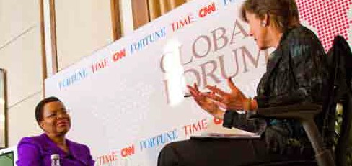Presented by Fortune and CCtV

12.30–14.30
ROuNDTABLE DISCuSSIONS

Technology, Innovation, and the Emerging World
How new technologies are changing the
emerging world — and how the emerging world is changing technology.

The Future of Transportation
Amid high oil prices and climate-change concerns, governments and the private sector are working together to create new, sustainable transportation systems.

Education to Employment: Designing a System that Works
Around the world, governments and businesses face a conundrum: high levels of youth unemployment and a shortage of job seekers with critical skills. How can countries successfully move people from education to employment?

Global Investment Strategies in an Era of Risk
In our hyper-connected global economy, what investment strategies should business leaders pursue to seize growth opportunities while managing their risk?

15.00–17.00
AFTERNOON SESSIONS

New Rules for Business: Global 500 Leaders Look Ahead
China’s economy is shifting, much of europe remains stuck in a recession, and the u.S. is merely
crawling along. Where is the global economy headed and what new trends will generate growth?

Tapping into China’s New Generation: An FGF Town Hall
In China, mass-market tastes are changing fast because of globalization, social media, and increasing affluence. What are the best strategies to tap into China’s popular culture over the next five years?

18.30–21.45
GALA DINNER AND KEYNOTE ADDRESS
this evening will include the keynote address and
a dazzling display featuring top artists from the disciplines of dance, drumming, opera, tai chi, and music. A creative blend of costumes, choreography, performance, and modern technology that spans the country’s cultural continuum will explore “the Dream of Chengdu” and “China’s new Future.”

Fortune Global Forum Photos by BradMarkel.com

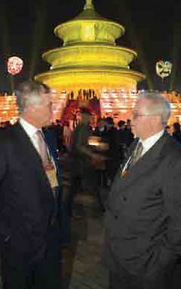

FRIDAy, 7 JuNE

8.30–12.40
MORNING SESSIONS

China’s Changing Economy
As China moves its economy away from exports and toward consumption, what reforms can we expect and what will be the impact of this tectonic shift? What are the opportunities and pitfalls?

Innovation: Building a Sustainable Future With the world population set to reach 9 billion by midcentury, today’s business leaders need to create a new set of rules and tools that will
allow their corporations to grow with less impact. What are the new r&D methodologies and disruptive technologies that will lead companies and countries on a more sustainable path?

Connecting with Women in the Emerging World Women are an important force in the emerging world, and it is crucial that business leaders understand their values, their challenges and their perspectives. What strategies work best and how do companies navigate the nuances across different markets?

The Next High Tech Wave
the Internet is ubiquitous, and mobility is not far behind. What are the next new trends that will drive growth in technology? What industries will be disrupted by technology next—education, agriculture, transportation, energy?

China’s Soft Power
How does a nation build its global influence and image in the world? Why have some countries been so successful in projecting their “soft power” while others struggled? China has an impressive story
to tell, yet it also faces some image challenges that must be overcome. How will China wield its “soft power” and what does this mean for the geopolitics and economics of the 21st century?

Can China Be Energy Independent?
With higher oil reserves and new access to natural gas, the u.S. could become energy independent for the first time. China might have even bigger shale gas reserves than the u.S. and its clean-energy industry has emerged from a major reshuffle.
Will China ever produce enough energy to be
self-sufficient and what is the route to get there?

The Future of Hardware
How smart is the smartphone (or the tablet or the PC)? With more and more intelligence
moving to networks and software, how will the device of the future differentiate itself?

unleashing Corporate China: SOEs and Private Enterprise
As beneficiaries of low-cost loans and land, China’s Soes exert significant power and influence in the economy. Some experts believe the Soes make
it difficult for private companies to launch and grow. What changes are needed in the system?

Winning in the China Market
China’s shift toward domestic consumption will create opportunities for both foreign and domestic brands to sell products. Luxury goods are in high demand, and China’s 350-million-strong middle class is displaying a growing appetite
for cars, clothes, and travel. Where do the opportunities lie and what are the barriers?

12.45–14.05
LuNCH
14.05–17.00
AFTERNOON SESSIONS

What’s Ahead for Emerging Markets?
over the last decade, the majority of economic growth has occurred in the so-called BrICS—but recently it has slowed. What’s the outlook for these economies? How can multinational corporations
capitalize on these increasingly important markets?

How Social Media is Changing Business
China has more than 500 million Internet users, twice the number in America. these Chinese users are changing how their society does everything from viewing the news to shopping. While China’s
weibos are thriving, the exuberance of their American counterparts has faded. How is social media changing the world and how should companies adapt?

The Chinese Tourist
A record 50 million Chinese traveled outside China in 2010 and hundreds of millions of locals flock to the country’s top tourist hot spots. Chinese tourists are reshaping the tourism industry as airlines, hotels, recreation parks, and brands scramble to offer
them a unique and positive experience. What are the opportunities to cater to this growing cadre of well-heeled world travelers in China and abroad?

Global Go-to-Market Strategies
Building a strong global brand can take decades and cost billions. there is much debate about how to go global: Is it more profitable to be in every country or to focus on a handful of key markets and service them well? As a growing number
of Chinese brands are entering international markets, which strategies work better?

Can Intellectual Property Be Kept Safe?
As the economy becomes more global, corporations have ramped up their efforts to protect their intellectual property, whether it’s a piece of software, a design
for a new router, or the latest box office hit. What are the best-in-class strategies for keeping IP safe?

Do You Know Who Your Suppliers Really Are?
With most products’ footprint found in the supply chain, knowing what suppliers are doing is vital to a business trying to lower costs, manage risk, and build brand identity. How can a business track and trace materials, parts, or components across its global supply chain?

Tapping into the Bottom of the Pyramid the good news is that the developing world is expanding. Some companies are figuring
out how to get products and services to these markets in ways that are both sustainable and profitable. What are the business models and what is the potential value of this market?

Rethinking Our Cities
For the first time, more Chinese live in cities than in the countryside. this trend is happening throughout the developing world. How will we design the cities of tomorrow to allow billions to live, drive, eat, and work sustainably? What new
technologies and design concepts can be applied to make urban centers greener and more livable?

17.00–18.30
FREE TIME

18.30–22.00
RECEPTION AND DINNER AT KuANZHSI XIANGZI
Hosted by Sichuan Province and the City of Chengdu, guests will enjoy a delicious dinner in this historic district that blends the architecture and ambience of old Chengdu City with modern style and energy, a place where past and present, local and global, fast and slow elements of Chengdu life meet.

SATuRDAy, 8 JuNE

8.30–13.00
MORNING SESSIONS

Growth and Conflict in the Asia Pacific
Greater economic interdependence has produced unprecedented dynamism that has created common interests and made Asia a central driver of global growth. But security issues including territorial disputes and a changing balance of power are raising tensions and jeopardizing the positive economic story. How will these forces play out? What policies will produce strategic stability that fosters economic growth? What are the prospects for integration and division in this vital region?

Meet the Future: China’s Entrepreneurs
Five of China’s most innovative emerging companies give their elevator pitches to a panel of notable venture capitalists, who evaluate each contestant. the winner will be the company that gets the most audience votes for best idea and most attractive investment.

What’s Next for Rural China?
two hundred million Chinese are constantly on the move seeking work. Yet, the promise of a job in the city is drying up as export markets shrink. How will China’s demographic trends evolve and what are the best strategies for meeting the needs of rural China? How can multinational and Chinese companies tap into the massive market of the country’s villages, townships, and smaller cities?

The Food Dilemma
As China has become more affluent, demands for agriculturally intensive foods have surged, putting an enormous strain on a system that feeds
1.3 billion people daily. How can new technologies and other adjustments help China feed itself sustainably, affordably, and nutritiously?

Corporate Risk and Climate Change
Globally, governments have failed to reach an agreement on climate change. traditional activist groups are putting pressure on corporations
to change their business practices as public awareness of environmental harm is increasing. How can companies manage their risk and minimize their cost of adapting to climate change?

Opening Hearts and Wallets
In the past 30 years, we’ve seen the remarkable rise of China’s wealthy class and a massive accumulation of personal fortunes. the widening wealth gaps, enormous social needs, and recent natural disasters seemed to rekindle an interest in charity nationwide. What lessons can Chinese business and philanthropic leaders learn from their Western counterparts, and vice versa?

Rewriting the Global Rule Book
For more than a decade, politicians and regulators worldwide have claimed to want high-quality accounting standards that applied globally to the banking system. When will that rhetoric become a reality? How will it change the game of global finance?

The Mobile Economy: An FGF Town Hall
Aided by higher-speed access, mobile devices are displacing everything from PCs to credit card readers, a consumer-driven shift that is prompting massive investments in infrastructure, software, handsets, and other technologies. As mobile computing becomes the world’s primary platform for communication, media, and transactions, society will be transformed and
companies will need to reinvent their business models.

The Rise of the West
the western provinces are now the fastest-growing region in China, and have become centers for high tech, automotive, finance, and other industries. More than 200 Fortune Global 500 companies now operate in
Chengdu, which has built a world-class infrastructure for trade. What are the opportunities and special challenges for operating in China’s dynamic new frontier?

KEYNOTE ADDRESS

13.00–14.00
CLOSING LuNCHEON

SuNDAy, 9 JuNE

8.00–16.00
SIDE TRIP TO SICHuAN EARTHquAKE DISASTER AND RECOVERY ZONE

SPouSE AND ComPANIoN PRoGRAm

The FORTuNE Global Forum offers complimentary registration for delegate’s spouses, who are invited to attend the gala dinners and selected activities, as well take part in an extraordinary concurrent program exploring Chengdu that is as insightful and memorable as the Forum itself.

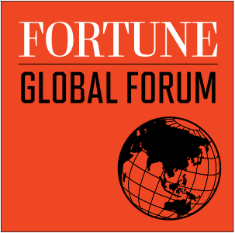

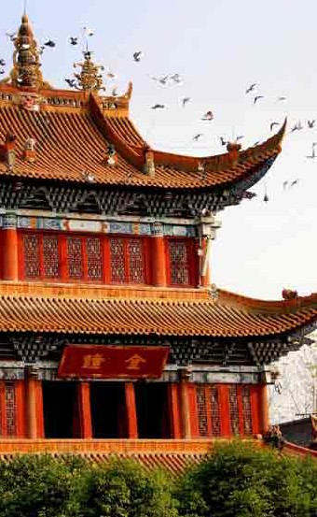hoST CITy: ChENGDu

Chengdu, one of China’s major inland cities, has seen dramatic economic gains since the China Western Development initiative was launched in 2000. Chengdu has long been known as “the Land of Abundance” and the home of the Giant Pandas. today it is becoming the most important financial center in western China. Selected by FORTuNE as one of the world’s “Best New Cities for Global Business,” Chengdu boasts a higher export volume and more Fortune Global 500 companies (over 200 now operate there), foreign-funded banks, insurance companies, and foreign consulates than any other city
in central or western China. With more than 30 institutions of higher learning in the region, Chengdu produces an unrivaled pool of talent with 21st-century skills.

HOST CITY PRESENTING PARTNER

PARTNERS

®

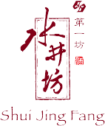

SuPPORTERS
eDuCAtIon PArtner

KnoWLeDGe PArtner

www.FortuneGlobalForum.com
e-mail: globalforum@fortune.com • tel (uSA): +1 212 522 3001 • Fax (uSA): +1 212 624 0258

Fortune and Fortune GLoBAL ForuM are trademarks of time Inc., registered in the u.S. and other countries. All other trademarks are the property of their respective owners.

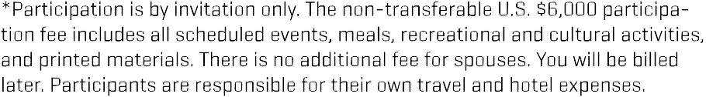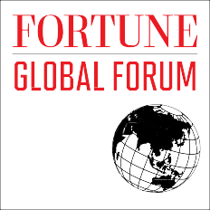

Dr. Hans d'Orville
Assistant Director-General, Strategic Planning Unesco
7, Place de Fontenoy F-75352 Paris 07 SP
France

